**Loss minimization interpretation:**

Main motive of logistic regression is to find minimum W which provides a smaller number of incorrectly classified points.  
So in Loss function, we consider +1 = incorrectly classified and 0 = Correctly classified. This type of function is called 0-1 loss function. Always we want to minimize loss and maximize the profit. This is an ideal loss function.  
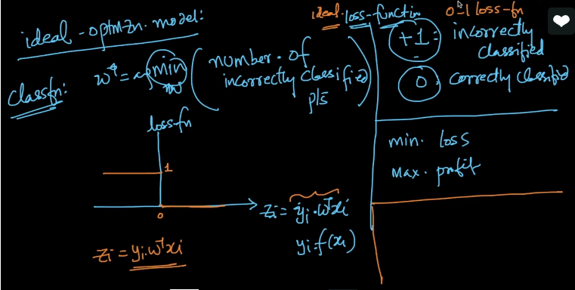  
Ideal loss function is  
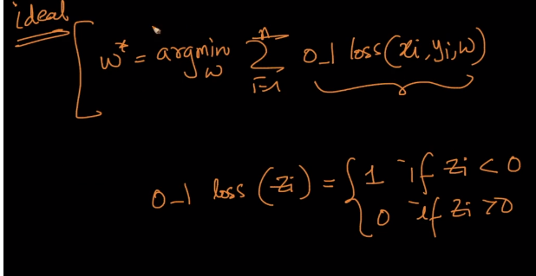  
But there is problem with above.  
To solve optimization problems in ML we use differentiation calculus. So problem is we cannot differentiate the not continues functions. 0-1 loss function is not – continues function because by looking on above pic, we know what the value is if Zi < 0 and Zi>0 but we don’t know the value when Zi =0. I can be any value. Look below pic, there is no continuity. We can differentiate in this case. By this reason , we cannot solve optimization problems using 0-1 loss function in ML.

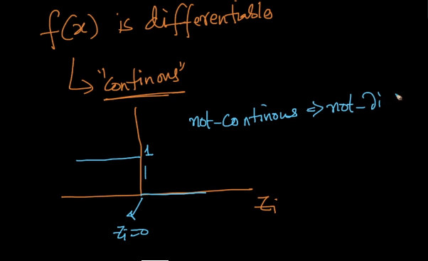

Since we cannot differentiate t he loss function, it’s decided to take approximate. One such approximation is, logistic loss function.  
X-axis, = Zi and Y-axis = Loss function.   
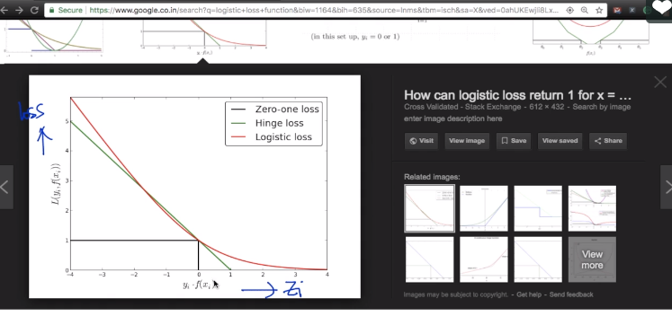  
So, when we use Logistic loss in Loss function we get Logistic regression. If we use, Hinge loss- we get SVM , If we use Expo – Loss we get Ada boost, If we use SQ-loss – we get linear regression.